Project Reference Number: 46S_BE_4800

Title of the project: AIR POLLUTION MONITORING, FORECASTING AND CONTROLLING SYSTEM

Name of the College: B.M.S. COLLEGE OF ENGINEERING

Name of the Department: INFORMATION SCIENCE AND ENGINEERING

Name of the Students: Mr. PRATEEK GUMMARAJU, Mr. SAMARTHA S, Ms. RUCHI AGARWAL

Name of the Guide: Mrs. PALLAVI B

Keywords: Air Quality Index, AQI, Pollution, AutoRegression, Moving Average, ARIMA, ARMA, Temperature, IoT, Sensors.

Introduction

One of the most important environmental problems affecting our planet right now is air pollution. It is now believed that air pollution is the largest environmental health risk on Earth, with 7 million deaths globally annually being attributable to it. With this project, we hope to successfully demonstrate the viability of a low-cost, Internet of Things based system constructed using Arduino and a variety of sensors that can not only monitor the current air quality but also predict the future and offer recommendations on how to reduce pollution and protect people from dangerous pollutants. We hope this system will help regulate and bring down the levels of air pollution and improve the quality of air, which in turn will improve the quality of lives of humans.
The main aim of the project is to model the Air Quality Index(AQI) of the Jayanagar-Basavanagudi region in order to be able to forecast the AQI for the coming 5 days. Just like how Temperature, Rainfall Probability, etc. are statistics that we consume on a daily basis before making plans to travel to a place, AQI is becoming an important factor.
In many industrial and urban areas today, maintaining and monitoring air quality has become a top priority. Numerous elements, such as time, temperature, pressure, wind speed and other factors play a role in determining the AQI. Due to the rising levels of air pollution, there is a great need to implement effective air quality monitoring systems that gather data on the concentration of various air pollutants and provide not only the current assessments of the level of pollution, but also predict the level of pollution in the near future. In addition to this, we find it essential to compare the pollution levels with the recommended limit given by organizations such as the World Health Organisation (WHO) and consequently provide measures to prevent the same. To achieve the same, we have built an IOT device that measures the concentration of pollutants throughout the day and gives the value of AQI, as well as a Machine Learning model (ARMAX) that can predict the AQI for the coming 5 days. We experimented with various models and features before choosing ARMAX.

Objectives

- Build an IoT system to monitor Air Quality:
  - a) Monitor Concentrations of different air pollutants
  - b) Measure AQI
- Build a model to predict the Air Quality in the near future, using the output of the IoT system as input.
- Build a web application to display the real time findings.
- Provide analytics on the website, such as current AQI and the forecasted AQI levels
- Provide measures to improve Air Quality.
- Provide precautionary measures.

Methodology

In order to build the IOT device, the components we needed were: Arduino Uno microcontroller, MQ135 sensor, MQ131 sensor, DHT11 sensor, MQ7 sensor, PM2.5 Dust Smoke Particle Sensor, NodeMCU, breadboard and connecting wires. The IoT device measured gas concentrations each second which were then averaged out over an hour, and further averaged out over a day to calculate the AQI.

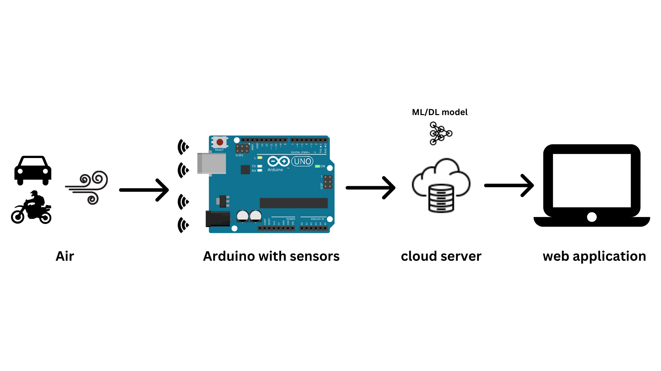
Fig 1: System Architecture

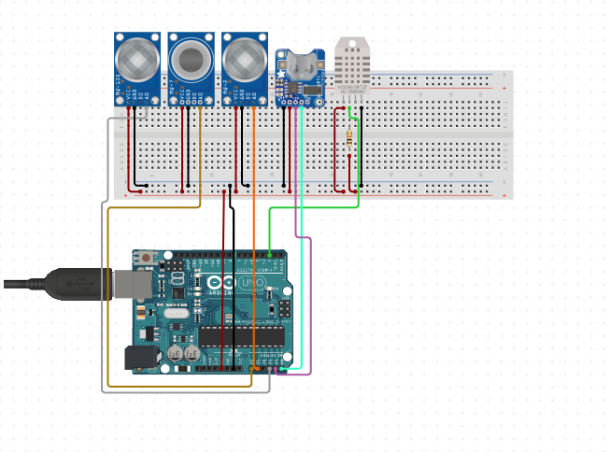
Fig 2: IOT Implementation

The data used to train and test the Machine Learning model was a combination of the data collected from the Central Pollution Control Board (CPCB - https://cpcb.nic.in/) and our IoT sensor explained in the previous section. The data collected was dated from 25th June 2018 to 1st May 2023. The Air Pollution monitoring station is situated in Jayanagar, 5th Block, Bangalore. From the open source data made available by CPCB, the following data points were collected (Note, all data points are daily averages) :- Concentrations of Particulate Matter 2.5, Particulate Matter 10, Oxides of Nitrogen, Carbon Monoxide, Ozone as we had found these to be the major contributing pollutants during the calculations of AQI. The other data points collected were Relative Humidity, Average Temperature, Wind Direction and Barometric Pressure. A separate data point called “Diwali” was added, as it was noted that the AQI was higher on the days of Diwali. The basic Machine Learning model used was AutoRegression.
The variants of the AutoRegression model were AR, ARMA, ARIMA, ARMAX , ARIMAX and SARIMA. All these models are time series models with other parameters.

Results and conclusions

Based on our experimentation, ARMAX model with (p,q,d) = (4,0,1) and exogenous variables being Average Temperature, Relative Humidity and Diwali gave us the best results, going by Mean Squared Error.

MODEL (Parameters) | Mean Squared Error (MSE)
Predicting based on previous day | 577.05
AutoReg(lags=17, trend=’t’) | 917.961
ARMA:  ARIMA(p=4, d=0, q=1, trend=’t’, exog=Null) | 449.86
ARIMA(p=3, d=1, q=1, trend=’t’, exog=Null) | 450.586
ARMAX(p=4,d=0,q=1, trend=’t’, exog=[‘Average Temperature’]) | 421.21
ARMAX(p=4,d=0,q=1, trend=’t’, exog=[‘Average Temperature’,’Diwali’]) | 220.125
ARMAX(p=4,d=0,q=1, trend=’t’, exog=[‘Relative Humidity’,’Wind Direction’]) | 176.463
ARMAX(p=4,d=0,q=1, trend=’t’, exog=[‘Average Temperature’,’Diwali’,‘Relative Humidity’,’Wind Direction’,’Barometric Pressure’]) | 145.075
ARMAX(p=4,d=0,q=1, trend=’t’, exog=[‘Average Temperature’,’Diwali’,‘Relative Humidity’]) | 125.52

With this project we not only aim to reduce the levels of air pollution, but also positively impact the lives of people by helping them change their lifestyle in such a way that it will encourage them to adopt some habits that will help reduce air pollution, which will help them, their pets and their environment to be healthier.

What is the innovation in the project?

This is the first time AQI has been modeled for a specific location. Until now, it was modeled for Bangalore as a whole, and going by government data, that was not accurate as different localities had different values. The usage of exogenous variables to predict AQI is another novel approach as all the current works use a basic Time Series approach.
Another problem that we are tackling is that, right now there is no place where we can access the future levels of AQI. We have seen that weather forecasting is very popular and many people all over the world keep a lookout for the predicted values of the weather. With air pollution becoming a very serious issue, we believe that people should start planning their outdoor activities based on the air pollution levels of that day. Hence we are creating a free to use web application that will show the current AQI and the forecasted AQI.
We are also providing the controls and measures to be taken when the AQI is at a particular value and how it can be brought back down to the recommended level.

Scope for future work
- Integrating the AQI forecast into Google Maps. Just like how Google gives push notifications of the weather rain forecast, it should give AQI forecasts as well.
- Automating the complete line of work, the device and model should work without any human interference, except for maintenance.
- We have built only one IoT device and have implemented it in only one location. Once we have established the proof of concept with this one location, we hope we can implement this on a much larger scale, covering much larger areas.

